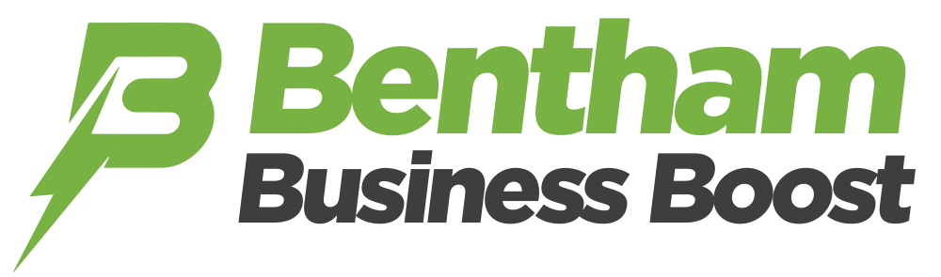  
  
**Shop front improvement grant application form**

Applications will close on Friday, 11 October 2024, at 5pm.

|  |  |
| --- | --- |
| Applicant Name |  |
| Address of the property which is the subject of the grant application |  |
| Business Name currently operating from the premises |  |
| Contact name for this application |  |
| Contact address if different to business address |  |
| Contact Email Address |  |
| Contact Telephone Number: |  |
| Type of Business: |  |
| Are You The Owner or Tenant?  (Please tick) | Owner  Tenant |
| Have you received permission from the owner, if required?  (Please tick) | Yes  No |
| Have you received planning permission, if necessary?  (Please tick) | Yes  No |
| Estimated cost of works (£): |  |
| Grant Amount sought (50% of cost, up to maximum grant value of £750): |  |
| Are you VAT registered:  (Please tick)  Please note that funding will not cover VAT where this can be recovered by the business | Yes  No |
| Detailed description of works to be carried out: |  |
| Proposed start date of works: |  |
| Estimation of time needed to complete works: |  |
| In order to be considered for the grant, you must send the following documents with your application to [townclerk@benthamtowncouncil.co.uk](mailto:townclerk@benthamtowncouncil.co.uk)  (Please tick all enclosed) | * copy of relevant plans, designs and/or sketches for proposed works * colour photographs of premises * confirmation from planning department that planning is not required/ planning permission has been granted * if renting, permission from landlord to carry out works * quote for proposed works |

**DECLARATION**

I declare that I have read, fully understand and agree with the terms and conditions of the scheme. I confirm that, where required, I have applied for all relevant consents or permission, statutory or otherwise. I am not in arrears as to any payment to North Yorkshire Council.

**Please Note:**

Your information will be shared with the Bentham Business Boost Project Group, NYC and the Y&NY Combined Authority; if successful we reserve the right to hold information of your application, subsequent work and publish photographs and details of chosen schemes before, during and after the improvements in promotional activities associated with the scheme and its purpose.

By signing you confirm that you have read and are in agreement with the declaration above and have read the Terms and Conditions:

Please sign to confirm your agreement

Print Name

Date

**N.B. Please read Terms and Conditions.**

